Congress Has Called for a Convention of States

In response to Congress’s increasing $37 trillion debt as a growing threat, the states have triggered an Article V FRA proposing convention. Congress has acknowledged the states threshold by receipt of the required applications. This is a true Turning Point for America.

The ‘Shall Call’ acknowledging the states authority occurred on September 14, 2025. What follows here is the position summary identifying that the states have now received full authority to call a fiscal responsibility amending convention, FRA, at their convenience.

The second clause of the Constitution’s Article V simply states: [The Congress…or,] “on the application of the legislatures of two thirds of the several states, shall call a convention for proposing amendments…”

Essentially, when 34 state applications, without qualification, have been received by Congress, that body shall announce their receipt. Historically, in over hundreds of non-Article V state conventions, the circular call letter sent by the host state inviting other states to meet identified the subject of the convention.

Records from the Article V Library were assembled and analyzed by FFSF (Federal Fiscal Sustainability Foundation) and confirmed by the NFC, (National Federalism Commission, a government entity) and publicly released on September 17, 2025 as validation of the 39 state applications authorizing a convention of states. In addition, the NFC also found that 36 other valid state applications were available to Congress in 2016.

In September 2025 the Article V Taskforce delivered packets of copies of the original 39 applications to the office of Congressman Jodey Arrington -TX-R, receiving acknowledgement of the 39 applications by the signed receipt below. Copies were also given to the House of Representative Clerk’s office, below, (who then forwarded them to the House Parliamentarian).

The solid footing for this action was settled by the Supreme Court’s ruling that the ‘bell had been wrung’ on the ratifications by the 3/4th state legislative vote, in Dillon v. Gloss (1921). It states the date of announcement, “is not material, for the date of its consummation, and not that on which it is proclaimed, controls.” Ergo, the 2/3rd state application in 1979 and 2016 also rang the bell for Congress to announce the states fulfillment of Article V’s threshold. They have not!

State legislative leaders now have confirmation of Article V’s authority to “shall call a convention for proposing amendments.” Its operation will follow the history of the 1787 Philadelphia, 2017 Phoenix BBA Planning and hundreds of other state conventions.

This is a call for state legislative leaders to Stand Up, Show Up, & Speak Up!

Michael W. Kapic - October 12, 2025


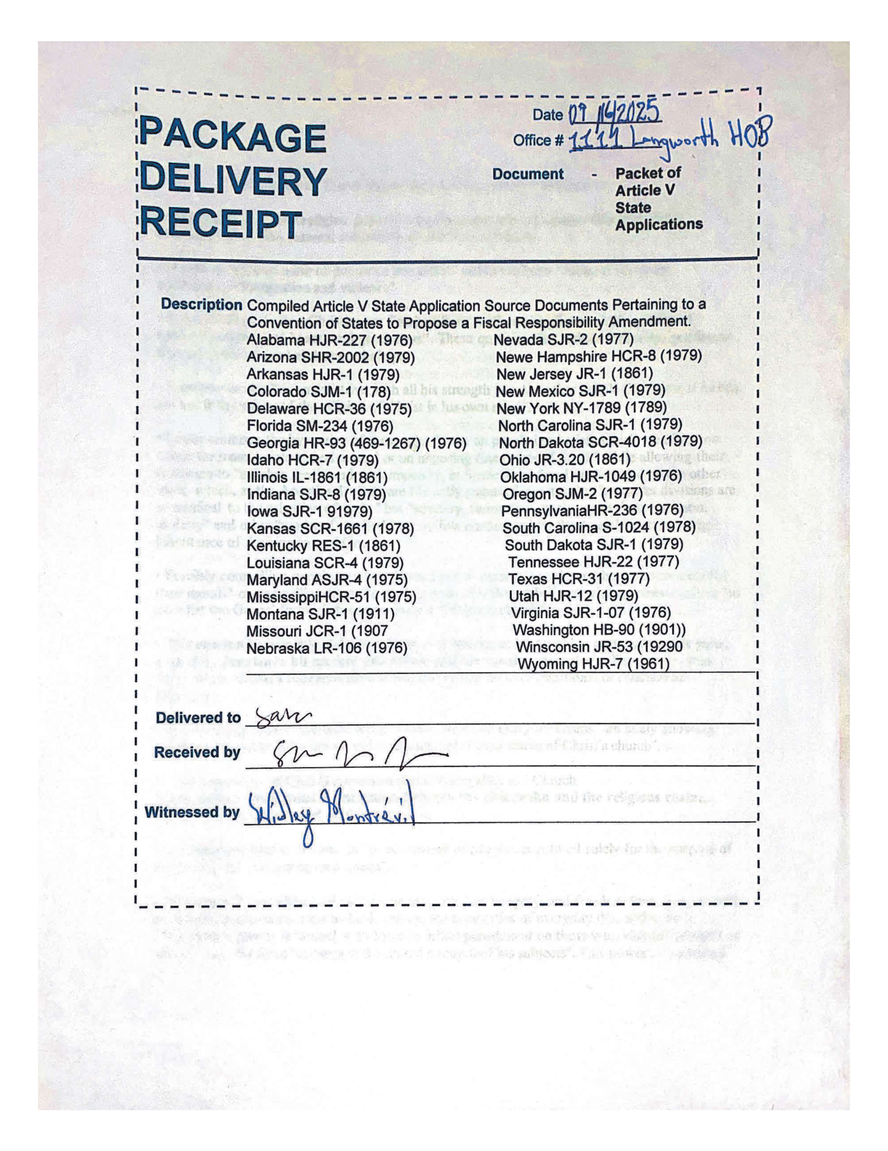

Receipt of the packet of 39 state applications by U.S. House Clerk:

---------- Forwarded message ---------
From: Lane, Philisha <Philisha.Lane@mail.house.gov>
Date: Thu, Sep 4, 2025 at 11:24 AM
Subject: RE: Tom Llewellyn - Package delivery receipt 8-14-25
To: Tom Llewellyn <tomdirect60@gmail.com>

Tom Llewellyn:

Thank you for contacting the Office of the Clerk.

I am confirming the Office of the Clerk received your correspondence on August 18, 2025 and your correspondence was transmitted to the Office of the Parliamentarian.

If you would like a status update, please contact your Representative in Congress at (202) 225-3121 for assistance.

Sincerely,

Philisha Lane
Office of the Clerk | Immediate Office
T: 202-225-7000
W: clerk.house.gov

